API Foundation
API = Application Programming Interface
An API allows two software applications to communicate with each other.
REST = Representational State Transfer
REST is an architectural style used for designing web APIs.
A REST API usually works with resources.
An endpoint is a specific URL through which we interact with an API.
Method | Purpose | Example
GET | Retrieve data | Get users
POST | Create data | Create user
PUT | Update entire resource | Update user
PATCH | Partially update resource | Update user's email
DELETE | Delete data | Delete user
HTTP Methods: HTTP stands for HyperText Transfer Protocol.
HTTPS is the secure version of HTTP.

HTTP Status Codes:
HTTP Status Codes:
Status codes tell us the result of an API request.
Code | Meaning
100 | Continue
101 | Switching Protocols
102 | Processing
Code | Meaning
200 | OK — request successful
201 | Created — resource successfully created
202 | Accepted — request accepted for processing
204 | No Content — successful, but no response body
Code | Meaning
301 | Moved Permanently
302 | Found / Temporary Redirect
304 | Not Modified
307 | Temporary Redirect
308 | Permanent Redirect
Code | Meaning
500 | Internal Server Error
501 | Not Implemented
502 | Bad Gateway
503 | Service Unavailable
504 | Gateway Timeout

Code | Meaning
400 | Bad Request — invalid request
401 | Unauthorized — authentication required/failed
403 | Forbidden — authenticated but not allowed
404 | Not Found — resource doesn't exist
405 | Method Not Allowed
408 | Request Timeout
409 | Conflict
415 | Unsupported Media Type
422 | Unprocessable Content
429 | Too Many Requests — rate limit exceeded
Authentication | Authorization
Identifies the user | Determines permissions
Who are you? | What can you do?
Happens first | Happens after authentication
Uses password, token, JWT, etc. | Uses roles, permissions, policies
Failure commonly → 401 | Failure commonly → 403
HTTP Headers:
Headers contain additional information about the request or response.
Content-Type: Tells the server what format the request body is in.
Authorization: Used to send authentication credentials/token.
Response headers: The server can return headers too.
Response Body: The server sends data back in the response body.
JSON = JavaScript Object Notation: It is one of the most commonly used formats for API communication.
Path Parameters: Path parameters are part of the URL.
Query Parameters: Query parameters come after ?.
Authentication Concepts:
Basic Authentication: Username + password.
Bearer Token: Very common in modern APIs.
Authentication vs Authorization:

API Analysis Sheet:
# | API | Method | Scenario | Input | Expected Status | Type
1 | /users | GET | Get all users | Valid request | 200 | Positive
2 | /users/1 | GET | Get existing user | ID = 1 | 200 | Positive
3 | /users/9999 | GET | Get non-existing user | Invalid ID | 404 | Negative
4 | /users | POST | Create user | Valid JSON | 201 | Positive
5 | /users | POST | Missing required field | Invalid JSON | 400 | Negative
6 | /users/1 | PUT | Update user | Valid JSON | 200 | Positive
7 | /users/1 | DELETE | Delete existing user | ID = 1 | 204/200 | Positive
8 | /users/9999 | DELETE | Delete non-existing user | Invalid ID | 404 | Negative
9 | /profile | GET | Without token | No Authorization | 401 | Negative
10 | /admin/users | GET | Normal user accesses admin API | Valid token, insufficient permission | 403 | Negative
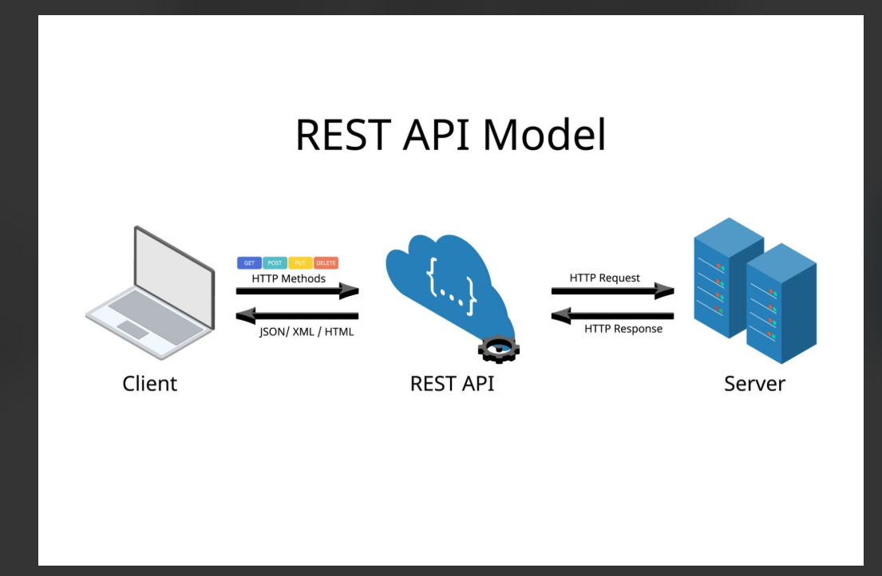
Real-World Example: Booking a Flight

